**HTML ASSIGNMENT**

1. Design a web page to print your name and address on it with appropriate format.

**HTML CODE:**

<html>

<head>

<title>BIODATA</title>

</head>

<body>

<p><b>Name:</b>Nikhil Nayak</p>

<p><b>Address:</b>BBSR, Odisha</p>

</body>

</html>

**OUTPUT:**

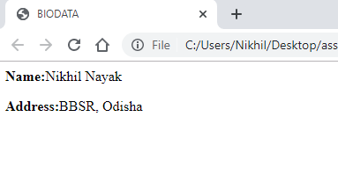

1. Design a web page to print the following output using text formatting tags.

**HTML CODE:**

<html>

<head>

<title>Text Format</title>

</head>

<body>

<p>This is <i>italized</i></p><br>

<p>This is <u>underlined</u></p>

<p>This is <b>bold</b></p><br>

<p>This is <em>emphasized</em></p>

<p>This is <strong>Strong text</strong></p>

<p>This is <s>striked text</s></p>

<p>This is computer code</p><br>

<p>This is <sup>superscript</sup>code</p>

<p>This is <sub>Superscript </sub> code</p>

<p>This is <big>big</big>text</p>

<p>This is <small>small</small>text</p>

</body>

</html>

**OUTPUT:**

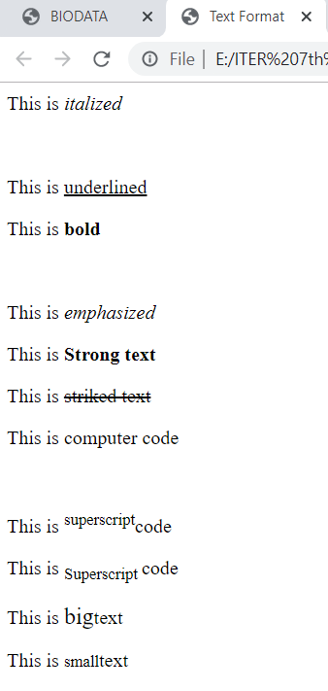

1. Design a web page to display the information of CSE / CSIT department of ITER by using basic page tags. Display the information in the form of paragraphs/sentences. Also use effects to highlight the information like bold, italic or underline.

**HTML CODE:**

<html>

<head>

<title>ITER</title>

<h1>ITER</h1>

</head>

<body>

<h3>CSE</h3>

<p><u>Computer Science Engineering</u> <b>(CSE)</b> encompasses a variety of topics that relates to <i>computation, like analysis of algorithms, programming languages, program design, software, and computer hardware</i>. Computer Science engineering has roots in electrical engineering, mathematics, and linguistics.</p>

<p>Computer Science engineering has roots in electrical engineering, mathematics, and linguistics.</p>

</body>

</html>

**OUTPUT:**

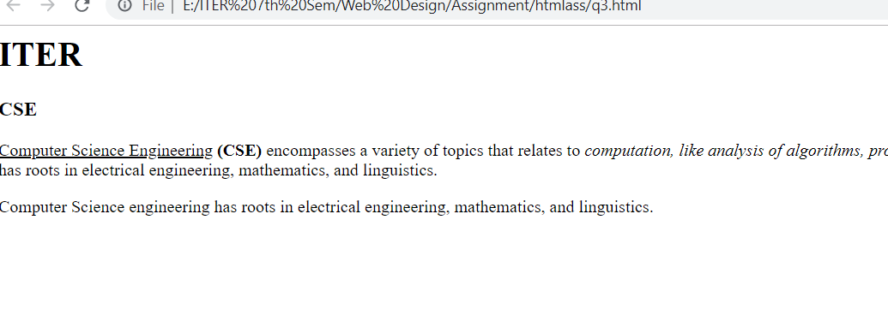

1. Design a web page using HTML to print your name and move it in both direction using appropriate tags.

**HTML CODE:**

<html>

<head>

<title>Name</title>

</head>

<body>

<marquee direction="right">Nikhil</marquee>

<marquee direction="left">Nikhil</marquee><br>

<marquee behavior="alternate"="right">Nikhil Nayak</marquee>

</body>

</html>

**OUTPUT:**

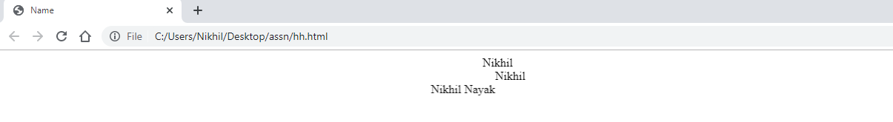

1. Design a web page to display the following output using ordered list.

**HTML CODE:**

<html>

<head>

<meta charset="utf-8">

<title>ordered list</title>

</head>

<body>

<p><b>Numbered list:</b></p>

<ol>

<li>Apples</li>

<li>Bananas</li>

<li>Lemons</li>

<li>Oranges</li>

</ol><br>

<p><b>Uppercase list:</b></p>

<ol type="A">

<li>Apples</li>

<li>Bananas</li>

<li>Lemons</li>

<li>Oranges</li>

</ol><br>

<p><b>Lowercase list:</b></p>

<ol type="a">

<li>Apples</li>

<li>Bananas</li>

<li>Lemons</li>

<li>Oranges</li>

</ol>

<p><b>Roman number list:</b></p>

<ol type="I">

<li>Apples</li>

<li>Bananas</li>

<li>Lemons</li>

<li>Oranges</li>

</ol>

<p><b> lowercase Roman number list:</b></p>

<ol type="i">

<li>Apples</li>

<li>Bananas</li>

<li>Lemons</li>

<li>Oranges</li>

</ol>

</body>

</html>

**OUTPUT:**

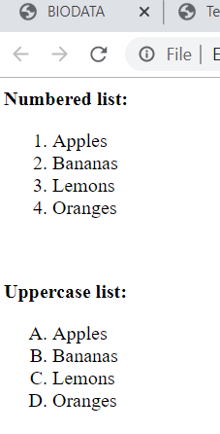

1. Design a web page to display the following output using unordered list.

**HTML CODE:**

<html>

<head>

<title></title>

</head>

<body>

<p><b>Disk bullet list:</b></p>

<ul style="list-style-type:disc;">

<li>Apples</li>

<li>Bananas</li>

<li>Lemons</li>

<li>Oranges</li>

</ul><br>

<p><b>circle bullet list:</b></p>

<ul style="list-style-type:circle;">

<li>Apples</li>

<li>Bananas</li>

<li>Lemons</li>

<li>Oranges</li>

</ul><br>

<p><b>Square bullet list:</b></p>

<ul style="list-style-type:Square;">

<li>Apples</li>

<li>Bananas</li>

<li>Lemons</li>

<li>Oranges</li>

</ul><br>

</body>

</html>

**OUTPUT:**

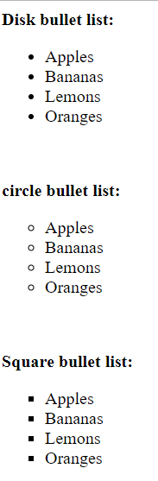

1. Design a web page to display the CSE / CSIT course structure of four years by using List tag.

**HTML CODE:**

<html>

<head>

<title>CSE course structure</title>

</head>

<body>

<h2>1st year</h2>

<p><b>1st sem</b></p>

<ol type ="I">

<li>ICP</li>

<li>UPM</li>

<li>Calculus 1</li>

<li>Dicrete Math</li>

<li>PME</li>

</ol><br>

<p><b>2nd sem</b></p>

<ol type ="I">

<li>DSA</li>

<li>IGT</li>

<li>Calculus 2</li>

<li>UPEM</li>

<li>IP</li>

</ol><br>

<h2>2nd year</h2>

<p><b>3rd sem</b></p>

<ol type ="I">

<li>ALA</li>

<li>PS</li>

<li>DL</li>

<li>electrical</li>

<li>PME</li>

</ol><br>

<p><b>4th sem</b></p>

<ol type ="I">

<li>NT</li>

<li>COA</li>

<li>PP 1</li>

<li>Ad 1</li>

<li>ES</li>

</ol><br>

<h2>3rd year</h2>

<p><b>5th sem</b></p>

<ol type ="I">

<li>IDB</li>

<li>AD 2</li>

<li>PP 2</li>

<li>NM</li>

<li>TC</li>

</ol><br>

<p><b>6th sem</b></p>

<ol type ="I">

<li>USP</li>

<li>DOS</li>

<li>PLC</li>

<li>FML</li>

<li>LEAE</li>

</ol><br>

<h2>4th year</h2>

<p><b>7st sem</b></p>

<ol type ="I">

<li>UNP</li>

<li>SEPA</li>

<li>TW</li>

<li>WEB DESIGN</li>

<li>PHP</li>

</ol><br>

<p><b>8th sem</b></p>

<ol type ="I">

<li>PROJECTS</li>

</ol><br>

</body>

</html>

**OUTPUT:**

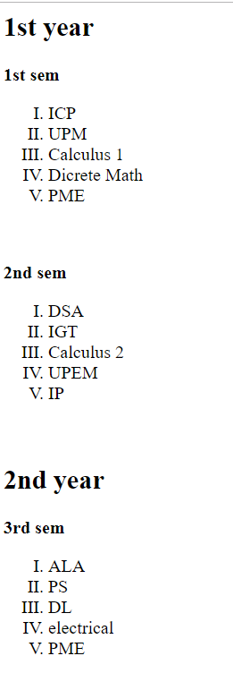

1. Create a hyperlink to show the information and syllabus of *Engineering* and *Management*. When clicked on the links each page should display the objective of respective course, fees, and duration.

**HTML CODE:**

<html>

<head>

<title>INFO PAGE</title>

</head>

<body>

<p>Click here for <a href="https://collegedunia.com/courses/bachelor-of-engineering-be-computer-engineering"> Engineering</a></p>

<p>Click here for <a href="https://collegedunia.com/courses/diploma-in-management"> Management</a></p>

</body>

</html>

**OUTPUT:**

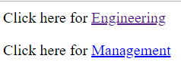

1. Create following table using necessary tags and attributes.

**HTML CODE:**

<html>

<head>

<title></title>

</head>

<style>

table,th,td{

border:1px solid black;

border-collapse: collapse;

}

</style>

<body>

<table style="width:100">

<tr>

<th>Name</th>

<th colspan="3">Marks</th>

</tr>

<tr>

<td> </td>

<td>JAVA</td>

<td>AI</td>

<td>CG</td>

</tr>

<tr>

<td>Sourav</td>

<td>92</td>

<td>86</td>

<td>85</td>

</tr>

<tr>

<td>Survi</td>

<td>88</td>

<td>84</td>

<td>87</td>

</tr>

</body>

</html>

**OUTPUT:**

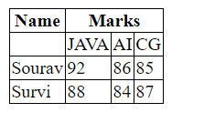

1. Design a web page to display the information in tabular format. Display the list of engineering colleges along with the details: Collage Name, Engineering stream, Address, Contact no. Address column will consist of sub columns city, area and pin code.

**HTML CODE:**

<html>

<head>

<title>student data</title>

<style>

table,th,td{

border:1px solid black;

border-collapse: collapse;

}

</style>

</head>

<body>

<table>

<tr>

<th>College Name</th>

<th>Stream</th>

<th colspan="3">Address</th>

<th>contact number</th>

</tr>

<tr>

<th colspan="2"></th>

<th>city</th>

<th>area</th>

<th>pincode</th>

<th></th>

</tr>

<tr>

<td>ITER</td>

<td>CSE</td>

<td>BBSR</td>

<td>Jagamara</td>

<td>751030</td>

<td>9439856656</td>

</tr>

</table>

</body>

</html>

**OUTPUT:**

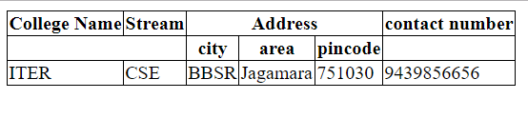

1. Create the following web page using frame.

**HTML CODE:**

<html>

<head>

</head>

<frameset rows="40%,30%,30%">

<frame src="a.html">

<frameset cols="10%,30%,60%">

<frame src="b.html">

<frame src="c.html">

<frame src="d.html">

</frameset>

<frameset cols="20%,80%">

<frame src="e.html">

<frame src="f.html">

</frameset>

</frameset>

</html>

**OUTPUT:**

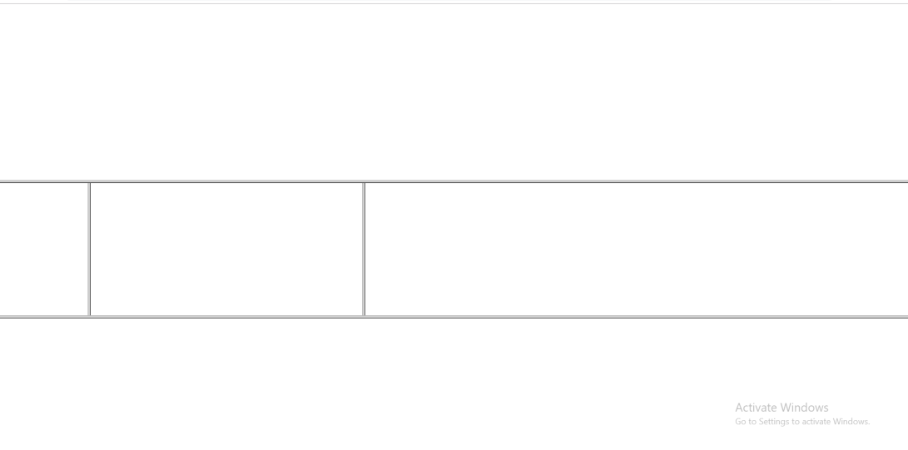

1. Create a sample of *SOA UNIVERSITY* web page.

**HTML CODE:**

<html>

<head>

</head>

<frameset cols="20%,80%">

<frame src="q12_1.html" name="frame1">

<frame name="frame2">

</frameset>

</html>

<html>

<head>

</head>

<body>

<ul>

<li><a href="E:\ITER 7th Sem\Web Design\Assignment\htmlass\q12_2.html" target="frame2">College Names</a></li>

<li><a href="E:\ITER 7th Sem\Web Design\Assignment\htmlass\q12_3.html" target="frame2">Contact Details</a></li>

</ul>

</body>

</html>

<html>

<head></head>

<body>

<h1>Colleges Under SOA</h1>

<br>

<ol>

<li>ITER</li>

<li>SUM</li>

<li>IDS</li>

<li>Agriculture</li>

<li>IBCS</li>

<li>Law</li>

<li>Hotel Management</li>

</ol>

</body>

</html>

<html>

<head>

</head>

<body>

<h1>Contact Details of SOA:</h1>

<br>

<b>Website:</b><a href="https://www.soa.ac.in">www.soa.ac.in</a>

</body>

</html>

**OUPUT:**

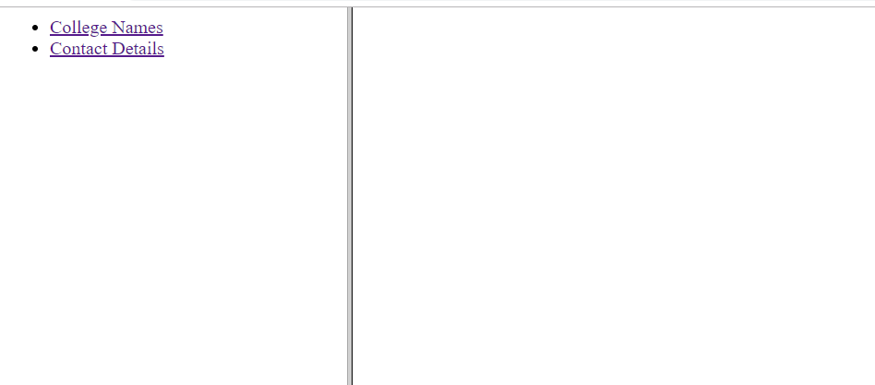

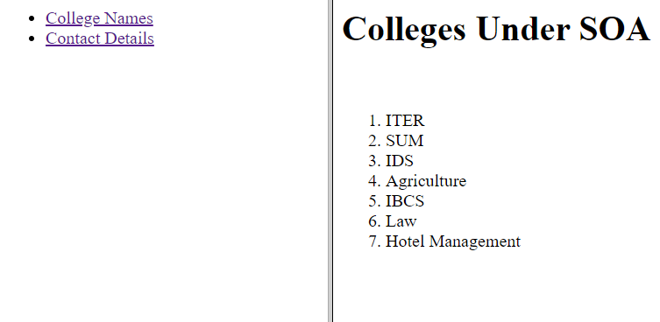

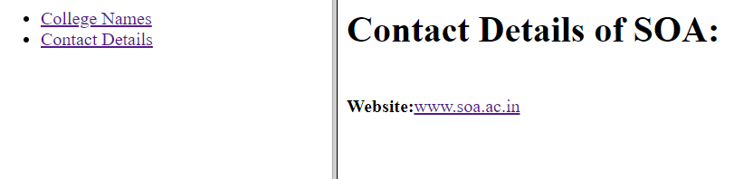

1. Design a web pages to accept the student information

**HTML CODE:**

<html>

<head>

</head>

<body>

<h1><center>Student Information</center></h1>

<br>

<form>

<p>First Name:<input type="text" name="fname">

<p>Last Name:<input type="text" name="lname">

<p>Middle Name:<input type="text" name="mname">

<p>City:<input type="text" name="city">

<p>Address:<br><textarea name="address" rows="5" cols="30"></textarea>

<p><label>Qualification:</label>

<select name="qual">

<option value="btech">BTECH</option>

<option value="mtech">MTECH</option>

<option value="phd">PHD</option>

<option value="mca">MCA</option>

</select></p>

<p><label>Gender:</label>

<select name="gender">

<option value="m">Male</option>

<option value="f">Female</option>

</select></p>

</form>

</body>

</html>

**OUTPUT:**

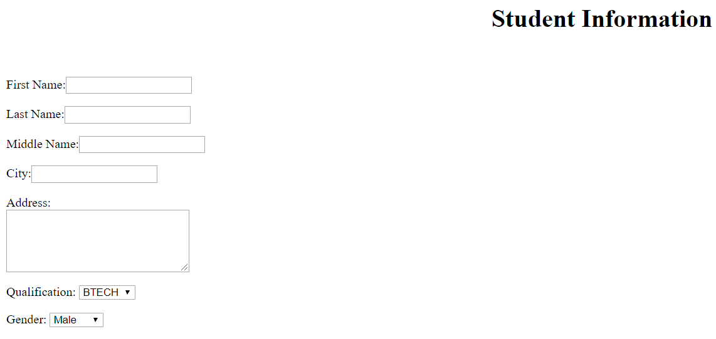

1. Design the following static web pages required for an online book store web site.

**HTML CODE:**

<html>

<head>

</head>

<frameset rows="32%,68%">

<frame src="q14_1.html" name="frame1">

<frameset cols="20%,80%">

<frame src="q14_2.html" name="frame2">

<frame src="q14_0.html" name="frame3">

</frameset>

</html>

<html>

<head></head>

<body>

<h1>ABOUT BOOKSTORE</h1>

<p> The website has a variety books ranging from different branches; CSE,CSIT,MECH,EEE,etc.

</body>

</html>

<html>

<head></head>

<body>

<img src="logo.jpg" alt="LOGO" width="100" height="100">

<h1><center>BOOKS WEBSITE</center></h1>

<br>

<a href="E:\ITER 7th Sem\Web Design\Assignment\htmlass\q14.html" target="frame3">Home</a>

<a href="E:\ITER 7th Sem\Web Design\Assignment\htmlass\q14_3.html" target="frame3">Login</a>

<a href="E:\ITER 7th Sem\Web Design\Assignment\htmlass\q14_4.html" target="frame3">Registration</a>

<a href="E:\ITER 7th Sem\Web Design\Assignment\htmlass\q14_5.html" target="frame3">Catalogue</a>

<a href="E:\ITER 7th Sem\Web Design\Assignment\htmlass\q14_6.html" target="frame3">Cart</a>

</body>

</html>

<html>

<head></head>

<body>

<a href="cse.html" target="frame3">CSE</a><br>

<a href="csit.html" target="frame3">CSIT</a><br>

<a href="ece.html" target="frame3">ECE</a><br>

<a href="eee.html" target="frame3">EEE</a><br>

<a href="mech.html" target="frame3">MECHANICAL</a><br>

<a href="civil.html" target="frame3">CIVIL</a><br>

</body>

</html>

<html>

<head></head>

<body>

<form>

<p>User ID:&nbsp;&nbsp;<input type="text" name="user">

<br><br>

<p>Password:&nbsp;&nbsp;<input type="password" name="pass">

<br><br>

<p><input type="submit" value="Submit">&nbsp;&nbsp;&nbsp;&nbsp;

<input type="reset" value="Reset">

</form>

</body>

</html>

<html>

<head></head>

<body>

<form>

<p>Name:<input type="text" name="name">

<p>Password:<input type="password" name="pass">

<p>Email:<input type="text" name="email">

<p>Phone:<input type="text" name="phone">

<p><label>Gender: </label>

<input type="radio" name="gender" value="male">Male

<input type="radio" name="gender" value="female">Female

<p>DOB:<input type="date" name="DOB">

<p><label>Languages Known:</label>

<input type="checkbox" name="lang" value="english">English

<input type="checkbox" name="lang" value="hindi">Hindi

<input type="checkbox" name="lang" value="odia">Odia

<p>Address:<br><textarea name="address" rows="5" cols="30"></textarea>

<br><br>

<input type="submit" value="Submit">

</form>

</body>

</html>

<html>

<head>

</head>

<body>

<table>

<caption>BOOKS DETAILS</caption>

<tr>

<th>Author Name</th>

<th>Publisher</th>

<th>Price</th>

</tr>

<tr>

<td>JK Rowling</td>

<td>HBS</td>

<td>500</td>

<td>&nbsp;&nbsp;&nbsp;<input type="submit" value="Add to Cart"></td>

</tr>

<tr>

<td>Enid Blyton</td>

<td>FAM</td>

<td>300</td>

<td>&nbsp;&nbsp;&nbsp;<input type="submit" value="Add to Cart"></td>

</tr>

</table>

</body>

</html>

<html>

<head>

</head>

<body>

<table>

<caption>CART PAGE</caption>

<tr>

<th>Book name</th>

<th>Price</th>

<th>Quantity</th>

<th>Amount</th>

</tr>

<tr>

<td>ICP</td>

<td>1000</td>

<td>1</td>

<td>1000</td>

</tr>

<tr>

<td>UNP</td>

<td>500</td>

<td>2</td>

<td>1000</td>

</tr>

</table>

</body>

</html>

**OUTPUT:**

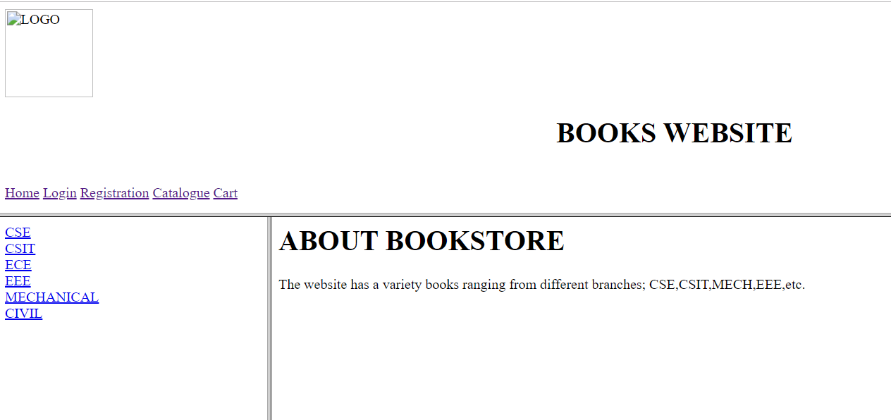

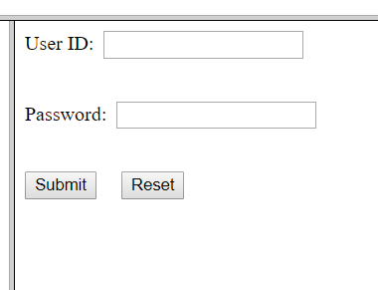

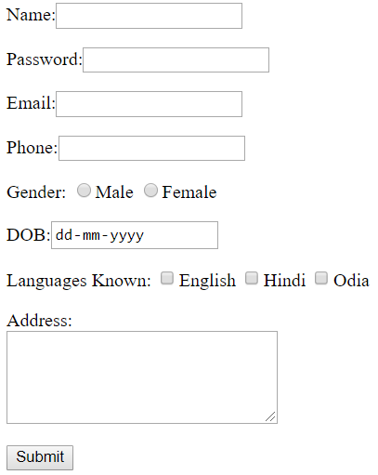

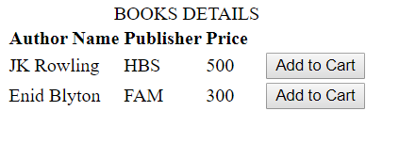

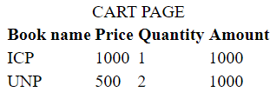

**CSS ASSIGNMENT**

1. Write a CSS rule that makes all text 2 times larger than the base font of the system and colors the text red.

**CODE:**

<html>

<head></head>

<body>

<p style="font-size: 2em; color: red">HELLO WORLD</p>

<body>

</html>

**OUTPUT:**



1. Write a CSS rules that gives all h1 and h2 elements a padding of 0.5 ems, a dashed border style and a margin of 0.5 ems.

**CODE:**

<html>

<head>

<style>

h1,h2

{

padding-top: 0.5em;

padding-right: 0.5em;

padding-bottom: 0.5em;

padding-left: 0.5em;

}

</style>

</head>

<body>

<h1>HELLO</h1>

<h2>EVERYONE</h2>

<body></html>

**OUTPUT:**



1. Write a CSS rule that places a background image halfway down the page, tiling it horizontally. The image should remain in place when the user scrolls up or down.

**CODE:**

<html>

<head>

<style>

body

{

background-image: url('C:\Users\lenovo\Desktop\Wallpapers\4k-3840-x-2160-wallpapers-themefoxx (4).jpg');

backround-repeat: no-repeat;

backround-size: 50% 100%

}

</style>

</head>

<body>

</body>

</html>

1. . Add an embedded style sheet to the HTML document. The style sheet should contain a rule that displays h1 elements in blue. In addition, create a rule that displays all links in blue without underlining them. When the mouse hovers over a link, change the link’s background color to yellow.

**CODE:**

<html>

<head>

<style>

h1

{

color: blue;

}

a

{

color: blue;

text-decoration: none;

}

a:hover

{

background-color: yellow;

}

</style>

</head>

<body>

<h1>GOOD MORNING</h1>

<br>

<a href="abc.html">GOOD</a>

</body>

</html>

**OUTPUT:**



1. The background color and the font color of inputs are customized by a separate CSS file. Instead of a separate style sheet how these colors styles can be mention inside the html file.

**CODE:**

<html>

<head>

<style>

body

{

background-color: black;

color: white;

}

</style>

</head>

<body>

hello

</body>

</html>

**OUTPUT:**



1. .Add an external style sheet to your 8th-semester-course management Web site by adding at least the following rules: Background color, margins, font family, font size• One Class• One ID•

**CODE:**

<html>

<head>

<link rel="stylesheet" href="\q6_1.css">

<style>

p.sem

{

font-family: "Times New Roman";

font-size: 16pt;

color: green;

}

#sub

{

font-size: 12pt;

color: green;

}

</style>

</head>

<body style="background-color: brown;

margin: 0 20%;">

<h1 style="font-family: 'Times New Roman';

font-size: 16pt;

color: green;">4th Year</h1>

<p id="sem" style="font-family: 'Times New Roman';

font-size: 16pt;

color: green;"><b>7th sem</b></p>

<ol type ="I">

<li class="sub">UNP</li>

<li class="sub">SEPA</li>

<li class="sub">TW</li>

<li class="sub">WEB DESIGN</li>

<li class="sub">PHP</li>

</ol><br>

<p id="sem"><b>8th sem</b></p>

<ol type ="I">

<li class="sub">PROJECTS</li>

</ol>

</body>

</html>

**OUTPUT:**



1. Using CSS file Create a Table tag where table border is 1px solid red; border-top-width is 3px and border-top-color is black.

**CODE:**

<html>

<head>

</head>

<body>

<table style="border: 1px solid red; border-top-width: 3px; border-top-color: black">

<caption>Details</caption>

<tr>

<th>REG</th>

<th>NAME</th>

</tr>

<tr>

<td>1</td>

<td>Raj</td>

</tr>

<tr>

<td>2</td>

<td>Ravi</td>

</tr>

<tr>

<td>3</td>

<td>Vickey</td>

</tr>

</table>

</body>

</html>

**OUTPUT:**

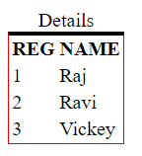

**TABLES ASSIGNMENT**

1. Write a program to create HTML table with the following output :

**CODE:**

<html>

<head>

<style type="text/css">

.studentInfo {

width: 500px;

border: 1px solid black;

}

</style>

</head>

<body>

<table class="studentInfo">

<tbody><tr>

<td>Name</td>

<td>Maths</td>

<td>Science</td>

<td>English</td>

<td>Physics</td>

<td>General Knowledge</td>

</tr>

<tr>

<td>David</td>

<td>85</td>

<td>87</td>

<td>88</td>

<td>92</td>

<td>88</td>

</tr>

<tr>

<td>Richard</td>

<td>91</td>

<td>81</td>

<td>78</td>

<td>71</td>

<td>74</td>

</tr>

<tr>

<td>John</td>

<td>81</td>

<td>86</td>

<td>88</td>

<td>84</td>

<td>92</td>

</tr>

<tr>

<td>Tony</td>

<td>84</td>

<td>86</td>

<td>87</td>

<td>82</td>

<td>81</td>

</tr>

<tr>

<td>Scott</td>

<td>71</td>

<td>79</td>

<td>82</td>

<td>88</td>

<td>89</td>

</tr>

</tbody></table>

</body>

</html>

**OUTPUT:**

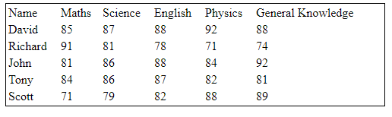

1. Write a program to create HTML table using CSS having following output:

**CODE:**

<html>

<head>

<style type="text/css">

.studentInfo {

width: 500px;

border: 1px solid black;

}

.header {

text-align:center;

font-weight:bolder;

}

</style>

</head>

<body>

<table class="studentInfo">

<tbody><tr>

<td class="header" colspan="6">STUDENTS MARK SHEET</td>

</tr>

<tr>

<td>Name</td>

<td>Maths</td>

<td>Science</td>

<td>English</td>

<td>Physics</td>

<td>General Knowledge</td>

</tr>

<tr>

<td>David</td>

<td>85</td>

<td>87</td>

<td>88</td>

<td>92</td>

<td>88</td>

</tr>

<tr>

<td>Richard</td>

<td>91</td>

<td>81</td>

<td>78</td>

<td>71</td>

<td>74</td>

</tr>

<tr>

<td>John</td>

<td>81</td>

<td>86</td>

<td>88</td>

<td>84</td>

<td>92</td>

</tr>

<tr>

<td>Tony</td>

<td>84</td>

<td>86</td>

<td>87</td>

<td>82</td>

<td>81</td>

</tr>

<tr>

<td>Scott</td>

<td>71</td>

<td>79</td>

<td>82</td>

<td>88</td>

<td>89</td>

</tr>

</tbody></table>

</body>

</html>

**OUTPUT:**

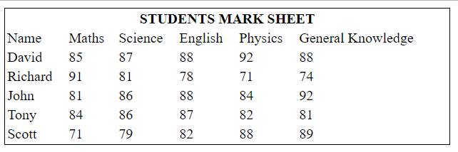

1. Write a program to create HTML table having cell borders using CSS to create following output:

**CODE:**

<html>

<head>

<style type="text/css">

.studentInfo {

width: 500px;

border-collapse: collapse;

}

.studentInfo td {

border: 1px solid black;

}

.header {

text-align: center;

font-weight: bolder;

}

</style>

</head>

<body>

<table class="studentInfo">

        <tbody><tr>

            <td class="header" colspan="6">STUDENTS MARK SHEET</td>

        </tr>

        <tr>

            <td>Name</td>

            <td>Maths</td>

            <td>Science</td>

            <td>English</td>

            <td>Physics</td>

            <td>General Knowledge</td>

        </tr>

        <tr>

            <td>David</td>

            <td>85</td>

            <td>87</td>

            <td>88</td>

            <td>92</td>

            <td>88</td>

        </tr>

        <tr>

            <td>Richard</td>

            <td>91</td>

            <td>81</td>

            <td>78</td>

            <td>71</td>

            <td>74</td>

        </tr>

        <tr>

            <td>John</td>

            <td>81</td>

            <td>86</td>

            <td>88</td>

            <td>84</td>

            <td>92</td>

        </tr>

        <tr>

            <td>Tony</td>

            <td>84</td>

            <td>86</td>

            <td>87</td>

            <td>82</td>

            <td>81</td>

        </tr>

        <tr>

            <td>Scott</td>

            <td>71</td>

            <td>79</td>

            <td>82</td>

            <td>88</td>

            <td>89</td>

        </tr>

    </tbody></table>

</body>

</html>

**OUTPUT:**

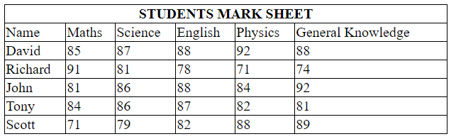

1. Write a program to create HTML table having border and alternate row background colors using CSS. Final output should be like this:

**CODE:**

<html>

<head>

<style type="text/css">

.studentInfo {

width: 500px;

border-collapse: collapse;

}

.studentInfo td {

border: 1px solid black;

}

.studentInfo tr:nth-child(even) {

background-color: #E4FFB7;

}

.studentInfo tr:nth-child(odd) {

background-color: #EFFFD2;

}

.header {

text-align: center;

font-weight: bolder;

background-color: #80B327;

color: white;

}

</style>

</head>

<body>

<table class="studentInfo">

        <tbody><tr>

            <td class="header" colspan="6">STUDENTS MARK SHEET</td>

        </tr>

        <tr class="mainRow">

            <td>Name</td>

            <td>Maths</td>

            <td>Science</td>

            <td>English</td>

            <td>Physics</td>

            <td>General Knowledge</td>

        </tr>

        <tr class="altRow">

            <td>David</td>

            <td>85</td>

            <td>87</td>

            <td>88</td>

            <td>92</td>

            <td>88</td>

        </tr>

        <tr>

            <td>Richard</td>

            <td>91</td>

            <td>81</td>

            <td>78</td>

            <td>71</td>

            <td>74</td>

        </tr>

        <tr>

            <td>John</td>

            <td>81</td>

            <td>86</td>

            <td>88</td>

            <td>84</td>

            <td>92</td>

        </tr>

        <tr>

            <td>Tony</td>

            <td>84</td>

            <td>86</td>

            <td>87</td>

            <td>82</td>

            <td>81</td>

        </tr>

        <tr>

            <td>Scott</td>

            <td>71</td>

            <td>79</td>

            <td>82</td>

            <td>88</td>

            <td>89</td>

        </tr>

    </tbody></table>

</body>

</html>

**OUTPUT:**

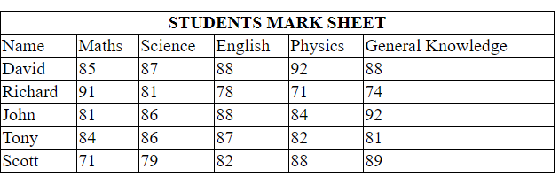

1. Write a program to create HTML table having border and alternate columns background colors using CSS. Final output should be like this:

**CODE:**

<html>

<head>

<style type="text/css">

        .studentInfo {

            width: 500px;

            border-collapse: collapse;

        }

            .studentInfo td {

                border: 1px solid black;

            }

                .studentInfo td:nth-child(even) {

                    background-color: #E4FFB7;

                }

                .studentInfo td:nth-child(odd) {

                    background-color: #EFFFD2;

                }

            .studentInfo tr:first-child td {

                text-align: center;

                font-weight: bolder;

                background-color: #80B327;

                color: white;

            }

    </style>

</head>

<body>

<table class="studentInfo">

       <tbody><tr>

           <td colspan="6">STUDENTS MARK SHEET</td>

       </tr>

       <tr class="mainRow">

           <td>Name</td>

           <td>Maths</td>

           <td>Science</td>

           <td>English</td>

           <td>Physics</td>

           <td>General Knowledge</td>

       </tr>

       <tr class="altRow">

           <td>David</td>

           <td>85</td>

           <td>87</td>

           <td>88</td>

           <td>92</td>

           <td>88</td>

       </tr>

       <tr>

           <td>Richard</td>

           <td>91</td>

           <td>81</td>

           <td>78</td>

           <td>71</td>

           <td>74</td>

       </tr>

       <tr>

           <td>John</td>

           <td>81</td>

           <td>86</td>

           <td>88</td>

           <td>84</td>

           <td>92</td>

       </tr>

       <tr>

           <td>Tony</td>

           <td>84</td>

           <td>86</td>

           <td>87</td>

           <td>82</td>

           <td>81</td>

       </tr>

       <tr>

           <td>Scott</td>

           <td>71</td>

           <td>79</td>

           <td>82</td>

           <td>88</td>

           <td>89</td>

       </tr>

   </tbody></table>

</body>

</html>

**OUTPUT:**

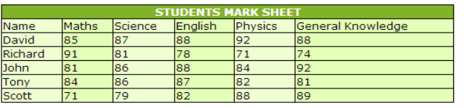

1. Write a program to create HTML table and apply border to its single cell using CSS. Final output should be like this:

**CODE:**

<html>

<head>

<style type="text/css">

.myTbl {

border-collapse: collapse;

width:500px;

}

.myTbl td {

border: 1px solid black;

}

.makeBorder {

border: 3px solid green !important;

}

</style>

</head>

<body>

<table class="myTbl">

<tbody><tr>

<td> </td>

<td> </td>

<td> </td>

</tr>

<tr>

<td> </td>

<td class="makeBorder"> </td>

<td> </td>

</tr>

<tr>

<td> </td>

<td> </td>

<td> </td>

</tr>

</tbody></table>

</body>

</html>

**OUTPUT:**

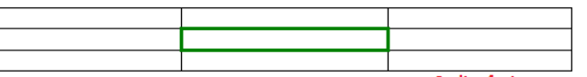

1. Write a program to create HTML table with the following output :

**CODE:**

<html>

<head>

<style type="text/css">

.myTable {

width: 500px;

border-collapse: collapse;

}

.myTable td {

border: 1px solid black;

}

</style>

</head>

<body>

<table class="myTable">

<tbody><tr>

<td><b>Company</b></td>

<td><b>Model</b></td>

</tr>

<tr>

<td>Dodge</td>

<td>Challanger</td>

</tr>

<tr>

<td>Maruti</td>

<td>Swift</td>

</tr>

<tr>

<td>Jeep</td>

<td>Wrangler</td>

</tr>

<tr>

<td rowspan="3">Ford</td>

<td>Fusion</td>

</tr>

<tr>

<td>Fiesta</td>

</tr>

<tr>

<td>Escape</td>

</tr>

<tr>

<td>BMW</td>

<td>BMW 5 Series</td>

</tr>

</tbody></table>

</body>

</html>

**OUTPUT:**

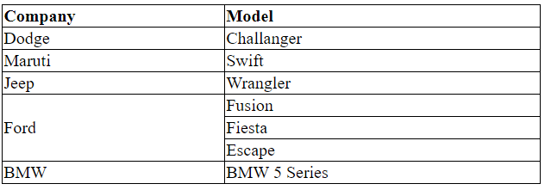

1. Write a program to create HTML table with the following output :

**CODE:**

<html>

<head>

<style type="text/css">

.myTable {

width: 500px;

border-collapse: collapse;

}

.myTable td {

border: 1px solid black;

}

</style>

</head>

<body>

<table class="myTable">

<tbody><tr>

<td><b>Company</b></td>

<td><b>Model</b></td>

</tr>

<tr>

<td>Dodge</td>

<td>Challanger</td>

</tr>

<tr>

<td>Maruti</td>

<td>Swift</td>

</tr>

<tr>

<td>Jeep</td>

<td>Wrangler</td>

</tr>

<tr>

<td colspan="2">All these car company names and their model names are collected from the internet. You can change Company and model name as per your choice.</td>

</tr>

<tr>

<td>BMW</td>

<td>BMW 5 Series</td>

</tr>

</tbody></table>

</body>

</html>

**OUTPUT:**

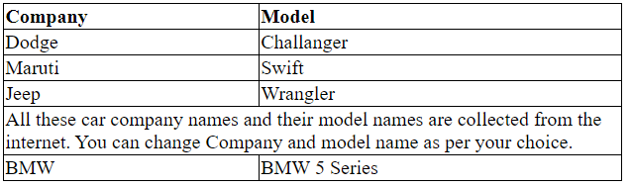

1. Write a program to create HTML table with the following output :

**CODE:**

<html>

<head>

<style type="text/css">

.myTable {

width: 500px;

border-collapse: collapse;

}

.myTable td {

border: 1px solid black;

}

</style>

</head>

<body>

<table class="myTable">

        <tbody><tr>

            <td><b>Company</b></td>

            <td><b>Model</b></td>

        </tr>

        <tr>

            <td>Dodge</td>

            <td>Challanger</td>

        </tr>

        <tr>

            <td>Maruti</td>

            <td>Swift</td>

        </tr>

        <tr>

            <td>Jeep</td>

            <td>Wrangler</td>

        </tr>

        <tr>

            <td style="vertical-align: top;">Disclaimer</td>

            <td>All these car company names and their model names are collected from the internet. You can chage Company and model name as per your choice.

                <br>

                All these car company names and their model names are collected from the internet. You can chage Company and model name as per your choice.

            </td>

        </tr>

        <tr>

            <td>BMW</td>

            <td>BMW 5 Series</td>

        </tr>

    </tbody></table>

</body>

</html>

**OUTPUT:**

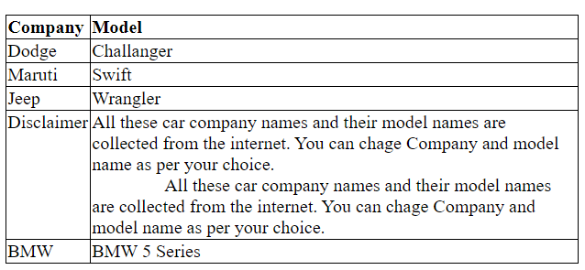

1. Write a program to create HTML table with the following output (make sure text have some space around them) :

**CODE:**

<html>

<head>

<style type="text/css">

.myTbl {

text-align: center;

border-collapse: collapse;

}

.myTbl td {

border: 1px solid black;

padding: 30px;

}

</style>

</head>

<body>

<table class="myTbl">

       <tbody><tr>

           <td><b>Sno</b></td>

           <td><b>Fruit Name</b></td>

           <td><b>Quantity</b></td>

       </tr>

       <tr>

           <td>1</td>

           <td>Orange</td>

           <td>60</td>

       </tr>

       <tr>

           <td>2</td>

           <td>Mango</td>

           <td>50</td>

       </tr>

       <tr>

           <td>3</td>

           <td>Pineapple</td>

           <td>30</td>

       </tr>

   </tbody></table>

</body>

</html>

**OUTPUT:**

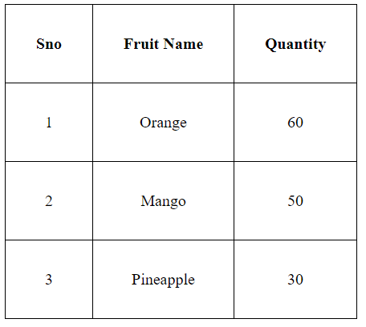

1. Write a program to create HTML table with the following output :

**CODE:**

<html>

<head>

<style type="text/css">

        .studentInfo {

            width: 500px;

            border: 1px solid black;

            border-collapse: collapse;

        }

            .studentInfo td {

                padding-left: 5px;

                border-right: 1px solid black;

            }

    </style>

</head>

<body>

<table class="studentInfo">

        <tbody><tr>

            <td>Name</td>

            <td>Maths</td>

            <td>Science</td>

            <td>English</td>

            <td>Physics</td>

            <td>General Knowledge</td>

        </tr>

        <tr>

            <td>David</td>

            <td>85</td>

            <td>87</td>

            <td>88</td>

            <td>92</td>

            <td>88</td>

        </tr>

        <tr>

            <td>Richard</td>

            <td>91</td>

            <td>81</td>

            <td>78</td>

            <td>71</td>

            <td>74</td>

        </tr>

        <tr>

            <td>John</td>

            <td>81</td>

            <td>86</td>

            <td>88</td>

            <td>84</td>

            <td>92</td>

        </tr>

        <tr>

            <td>Tony</td>

            <td>84</td>

            <td>86</td>

            <td>87</td>

            <td>82</td>

            <td>81</td>

        </tr>

        <tr>

            <td>Scott</td>

            <td>71</td>

            <td>79</td>

            <td>82</td>

            <td>88</td>

            <td>89</td>

        </tr>

    </tbody></table>

</body>

</html>

**OUTPUT:**

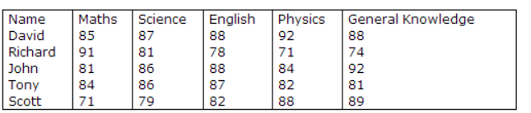

1. Write a program to create HTML table with the following output :

**CODE:**

<html>

<head>

<style type="text/css">

       .studentInfo {

           width: 500px;

           border: 1px solid black;

           border-collapse: collapse;

       }

           .studentInfo td {

               padding-left: 5px;

               border-bottom: 1px solid black;

           }

   </style>

</head>

<body>

<table class="studentInfo">

        <tbody><tr>

            <td>Name</td>

            <td>Maths</td>

            <td>Science</td>

            <td>English</td>

            <td>Physics</td>

            <td>General Knowledge</td>

        </tr>

        <tr>

            <td>David</td>

            <td>85</td>

            <td>87</td>

            <td>88</td>

            <td>92</td>

            <td>88</td>

        </tr>

        <tr>

            <td>Richard</td>

            <td>91</td>

            <td>81</td>

            <td>78</td>

            <td>71</td>

            <td>74</td>

        </tr>

        <tr>

            <td>John</td>

            <td>81</td>

            <td>86</td>

            <td>88</td>

            <td>84</td>

            <td>92</td>

        </tr>

        <tr>

            <td>Tony</td>

            <td>84</td>

            <td>86</td>

            <td>87</td>

            <td>82</td>

            <td>81</td>

        </tr>

        <tr>

            <td>Scott</td>

            <td>71</td>

            <td>79</td>

            <td>82</td>

            <td>88</td>

            <td>89</td>

        </tr>

    </tbody></table>

</body>

</html>

**OUTPUT:**

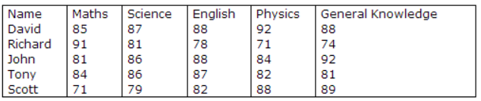

**JAVASCRIPT ASSIGNMENT**

1. Write java script code to take two integer inputs from user and a valid arithmetic operator. Perform the operation and display the result back to the user.

**CODE:**

<html>

<head>

<title>javascript: calculate two numbers</title>

<script>

function calc()

{

var n1 = parseFloat(document.getElementById('n1').value);

var n2 = parseFloat(document.getElementById('n2').value);

var oper = document.getElementById('operators').value;

if(oper === '+')

{

document.getElementById('result').value = n1+n2;

}

if(oper === '-')

{

document.getElementById('result').value = n1-n2;

}

if(oper === '/')

{

document.getElementById('result').value = n1/n2;

}

if(oper === 'X')

{

document.getElementById('result').value = n1*n2;

}

}

</script>

</head>

<body>

<label>Number1</label>

<input type="text" id="n1"/><br/><br/>

<label>Number2</label>

<input type="text" id="n2"/><br/><br/>

<select id="operators">

<option value="+">+</option>

<option value="-">-</option>

<option value="/">/</option>

<option value="X">X</option>

</select>

<button onclick="calc();">=</button>

<input type="text" id="result"/>

</body>

</html>

**OUTPUT:**

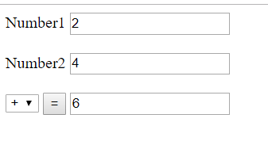

1. Write a program using JavaScript to receive four numbers from text boxes and display biggest,smallest, sum and average of the numbers.

**CODE:**

<html>

<head>

<title>Compare Numbers</title>

<script type="text/javascript">

var firstNumber,secondNumber,thirdNumber,

fourthNumber,sum,average,product;

firstNumber = window.prompt("Enter first integer");

secondNumber = window.prompt("Enter second integer");

thirdNumber = window.prompt("Enter third integer");

fourthNumber = window.prompt("Enter fourth integer");

firstNumber = parseInt(firstNumber);

secondNumber = parseInt(secondNumber);

thirdNumber = parseInt(thirdNumber);

fourthNumber=parseInt(fourthNumber)

findLargNum(firstNumber,secondNumber,thirdNumber,fourthNumber);

function findLargNum(firstNumber,secondNumber,thirdNumber,fourthNumber){

//determine result

if (firstNumber > secondNumber) {

if(firstNumber > thirdNumber && firstNumber>fourthNumber) window.alert(firstNumber + " is largest");

}

else if(secondNumber > thirdNumber && secondNumber>fourthNumber) window.alert(secondNumber + " is largest");

else if(thirdNumber>fourthNumber)window.alert(thirdNumber + " is largest");

else window.alert(fourthNumber + " is largest");

var sum = firstNumber + secondNumber + thirdNumber+fourthNumber;

window.alert("the sum is " + sum);

var average = (firstNumber + secondNumber + thirdNumber+fourthNumber) / 4;

window.alert("the average is " + average);var product = firstNumber * secondNumber * thirdNumber*fourthNumber;window.alert("the product is" + product);

}

</script>

</head>

<body>

<h1 style = "text-align:center">Compare the Integers!</h1>

</body>

</html>

**OUTPUT:**

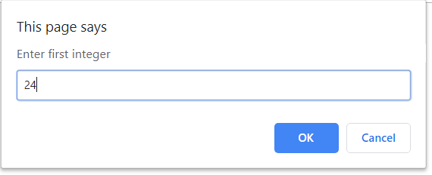



1. Write java script code to check a given no is prime or not using function. The output should look like as follows:

**CODE:**

<html>

<head>

<title>

Check a number is Prime or

not using JavaScript

</title>

<script type="text/javascript">

// Function to check prime number

function p() {

var n, i, flag = true;

// Getting the value form text

// field using DOM

n = document.myform.n.value;

n = parseInt(n)

for(i = 2; i <= n - 1; i++)

if (n % i == 0) {

flag = false;

break;

}

// Check and display alert message

if (flag == true)

alert(n + " is prime");

else

alert(n + " is not prime");

}

</script>

</head>

<body>

<h4>check number is prime or not</h4>

<hr color="Green">

<form name="myform">

Enter the number:

<input type="text" name=n value="">

<br><br>

<input type="button" value="Check" onClick="p()">

<br>

</form>

</body>

</html>

**OUTPUT:**

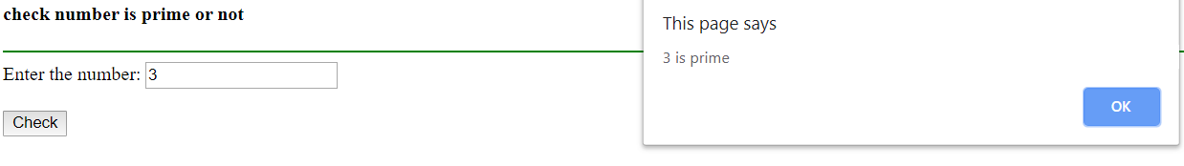

1. Write java script code to search an element in an array of size N using function.

**CODE:**

<html>

<head>

<title>linear</title>

<script type="text/javascript">

function linear()

{

var n=parseInt(prompt("Enter the size of an array"));

var a=new Array(n);

var t=0;

for(var i=0; i<a.length; i++)

{

a[i]=parseInt(prompt("Enter array elements"));

}

var k=parseInt(prompt("Enter the key element to search: "));

for(var i=0; i<a.length; i++)

{

if(k==a[i])

{

t=1;

break;

}

}

if(t==1)

{

document.writeln("Element "+a[i]+ " Found at Position:"+i);

}

else

{

document.writeln("Element Not Found");

}

}

</script>

</head>

<body onLoad="linear()"></body>

</html>

**OUTPUT:**

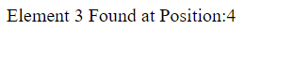

1. Write java script code to compute GCD of two numbers using function.

**CODE:**

<html>

<head>

<title>GCD of two numbers</title>

<script type="text/javascript">

var gcd = function(a, b) {

if (b == 0) {

return a;

}

return gcd(b, a % b);

};

document.write(gcd(1263262,553443));

</script>

</head>

</html>

**OUTPUT:**



1. Write java script code to find the second largest number in an array using function.

**CODE:**

<head>

<title>Second largest number</title>

<script type="text/javascript">

function Second_Largest(arr_num)

{

arr_num.sort(function(x,y)

{

return x-y;

});

var uniqa = [arr_num[0]];

var result = [];

for(var j=1; j < arr_num.length; j++)

{

if(arr_num[j-1] !== arr_num[j])

{

uniqa.push(arr_num[j]);

}

}

result.push(uniqa[uniqa.length-2]);

return result.join(',');

}

document.write(Second_Largest([1,10,3,8,9]));

</script>

</head>

<body>

</body>

**OUTPUT:**



1. Write java script code to check whether the given integer is palindorme or not using function.

**CODE:**

<html>

<head>

<script>

function Palindrome()

{

var rem, temp, final = 0;

var number = Number(document.getElementById("N").value);

temp = number;

while(number>0)

{

rem = number%10;

number = parseInt(number/10);

final = final*10+rem;

}

if(final==temp)

{

window.alert("The inputed number is Palindrome");

}

else

{

window.alert("The inputted number is not palindrome");

}

}

</script>

</head>

<body>

<br>

<h1>Whether a number is Palindrome or not</h1>

Enter The Number :<input type="text" name="n" id = "N"/>

<hr color="cyan">

<br>

<button onClick="Palindrome()">CHECK

</body>

</html>

**OUTPUT:**

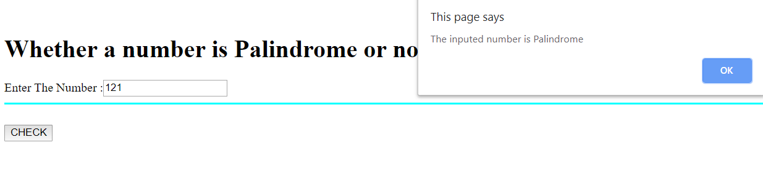

1. Design a Form which when Submitted must validate the Name field as it must not exceed 30 characters, Registration Number as containing 10 digits and email address must contain “@” and “**.**” . Symbols, using JavaScript as the scripting technique.

**CODE:**

<html>

<head>

<script>

function f()

{

var name=document.registration.name;

var reg=document.registration.reg;

var email=document.registration.mail;

window.alert(name.value);

var name_l=name.value.length;

var reg_l=reg.value.length;

var filter = /^([a-zA-Z0-9_\.\-])+\@(([a-zA-Z0-9\-])+\.)+([a-zA-Z0-9]{2,4})+$/;

if(name_l>30||reg_l>10||!filter.test(email.value))

{

if(name_l>30)

window.alert("Name Character exceeded by 30");

else if(reg_l>10)

window.alert("Registration no. is of 10 digits");

else if(!filter.test(email.value))

window.alert('Please provide a valid email address');

}

else

window.alert("Succesfull");

}

</script>

</head>

<body>

<h1>FORM</h1>

<form name="registration" onSubmit="return f()";>

<label>Name</label>

<input type="text" name="name"><br><br>

<label>Registration Number</label>

<input type="text" name="reg"><br><br>

<label>Email</label>

<input type="text" name="mail"><br><br>

<br><br>

<input type="submit" value="Submit">

</form>

</body>

</html>

**OUTPUT:**

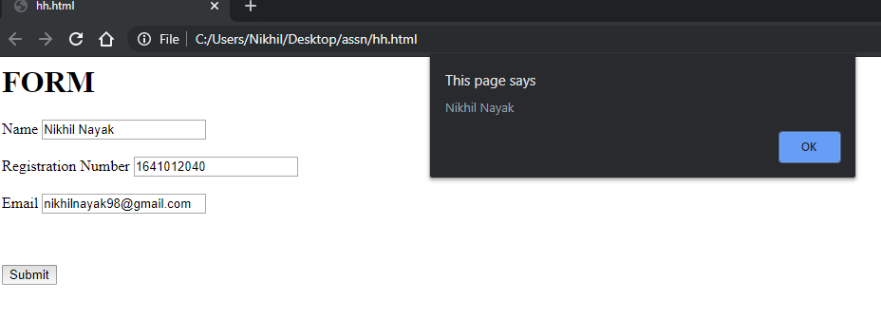

1. Write JavaScript and HTML code that asks the user how many marbles he has and then tells the user how many gross, how many dozen and how many extra marbles are left over. (1gross = 144 no. and 1 dozen = 12 no.) [Hint: If the user says that he has 1342 marbles, then the program would respond: “You have 9 gross, 3 dozen, and 1 marbles with you”.]

**CODE:**

<html>

<head>

<script>

var n=window.prompt("Enter the number of marbles");

var gross,dozen;

gross=Math.floor(n/144);

n=n%144;

dozen=Math.floor(n/12);

n=n%12;

window.alert("You have "+gross+" gross, "+dozen+" dozens and "+n+" marbles with you");

</script>

</head>

</html>

**OUTPUT:**

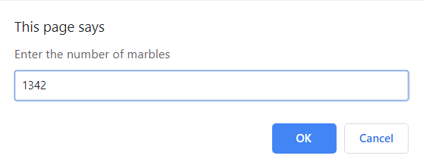

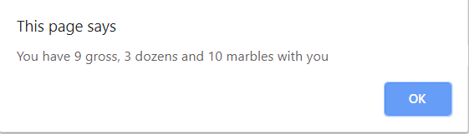

1. Write the JavaScript code to take the value of an integer variable *n*, calculate Factorial of *n* and display the result on to a browser.

**CODE:**

<html>

<head>

<script>

var n=window.prompt("Enter the number");

var fact=1;

while(n!=0)

{

fact=fact*n;

n--;

}

document.write("Factorial="+fact);

</script>

</head>

</html>

**OUTPUT:**

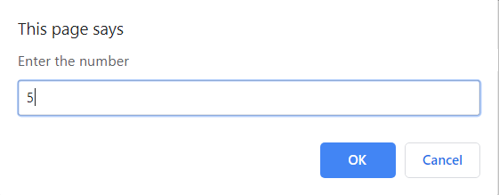

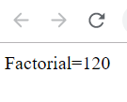

1. Write a JavaScript embedded HTML code to input first name, middle name and last name of a user. Display the full name of the user. Display the abbreviated name of the user.Count the number of times a user specified character is appearing in the name. Look for a substring in the name too.

**CODE:**

<html>

<head>

<script>

function f()

{

var fname=document.registration.fname;

var mname=document.registration.mname;

var lname=document.registration.lname;

window.alert("Fullname: "+fname.value+" "+mname.value+" "+lname.value);

window.alert("Abbreviated name: "+fname.value.charAt(0)+"."+mname.value.charAt(0)+". "+lname.value);

}

</script>

</head>

<body>

<form name="registration" onsubmit="return f()";>

<p><label>First Name</label>

<input type="text" name="fname">

<p><label>Middle Name</label>

<input type="text" name="mname">

<p><label>Last Name</label>

<input type="text" name="lname">

<br><br>

<input type="submit" value="Submit">

</form>

</body>

</html>

**OUTPUT:**

